**DAILY ONLINE ACTIVITIES SUMMARY**

|  |  |  |  |  |  |  |  |  |
| --- | --- | --- | --- | --- | --- | --- | --- | --- |
| **Date:** | **06/06/2020** | | | | | **Name:** | **Anjali Manohar Prabhu** | |
| **Sem & Sec** | **4th Sem Section - ‘A’** | | | | | **USN:** | **4AL18CS007** | |
| **Online Test Summary** | | | | | | | | |
| **Subject** | | **Data Communication** | | | | | | |
| **Max. Marks** | | **30** | | **Score** | | | **26** | |
| **Certification Course Summary** | | | | | | | | |
| **Course** | **Cloud Foundation** | | | | | | | |
| **Certificate Provider** | | | 1. **Great Learning Academy** | | **Duration** | | | **5.0hrs** |
| **Coding Challenges** | | | | | | | | |
| **Problem Statement:**   1. **Write a c program to rotate an array by N position** | | | | | | | | |
| **Status: executed** | | | | | | | | |
| **Uploaded the report in Github** | | | | | **YES** | | | |
| **If yes Repository name** | | | | | [**https://github.com/vinisharen/lockdown-coding**](https://github.com/vinisharen/lockdown-coding) | | | |
| **Uploaded the report in slack** | | | | | **YES** | | | |

Online Test Details: DC test was conducted as per the given timings, that is from 9:30 am to 10:15 am and portion for the test was ”MODULE 5”. There were 30 questions in total and the time limit for the test was 45 min. each question consist if 1 mark and the marks I scored was 26/30

**SNAPSHOT:**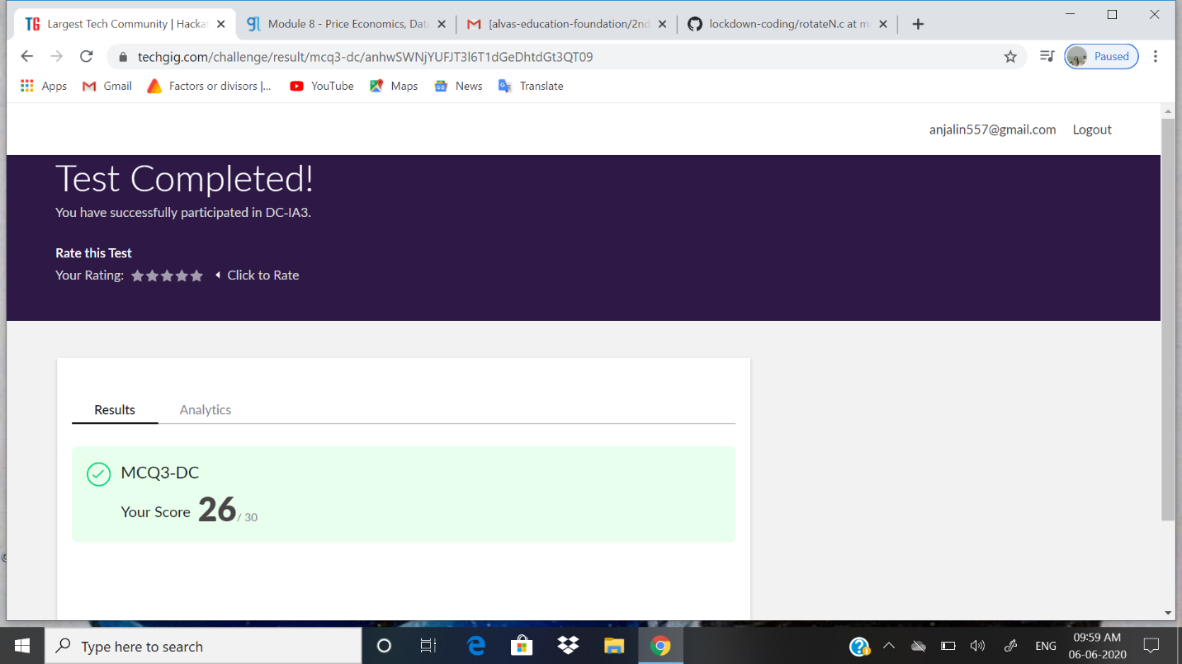

Certification Course Details: In January 2015, the Cloud Foundry Foundation was created as an independent not-for-profit 501(c)(6) [Linux Foundation](https://en.wikipedia.org/wiki/Linux_Foundation) Collaborative Project.[[11]](https://en.wikipedia.org/wiki/Cloud_Foundry#cite_note-11)

Following the creation of the Cloud Foundry Foundation, the Cloud Foundry software (source code and all associated trademarks) was transferred to be held by the open source software foundation. It is primarily written in [Ruby](https://en.wikipedia.org/wiki/Ruby_(programming_language)), [Go](https://en.wikipedia.org/wiki/Golang) and [Java](https://en.wikipedia.org/wiki/Java_(programming_language)).[[12]](https://en.wikipedia.org/wiki/Cloud_Foundry#cite_note-12)

As of February 2019, the Foundation had 65 members.[[13]](https://en.wikipedia.org/wiki/Cloud_Foundry#cite_note-13)

The foundation serves as a neutral party holding all Cloud Foundry [intellectual property](https://en.wikipedia.org/wiki/Intellectual_property). Once intellectual property is contributed to Cloud Foundry, it becomes property of the Foundation and these assets cannot be transferred to for-profit entities, as per the laws governing 501(c)(6) organizations. The Foundation holds two contributed types of intellectual property: trademarks and a copyright on the [collective work](https://en.wikipedia.org/wiki/Collective_work) of the community. It also has a license to use and re-license all code contributions, but does not own copyright on those contributions.

**SNAPSHOT:**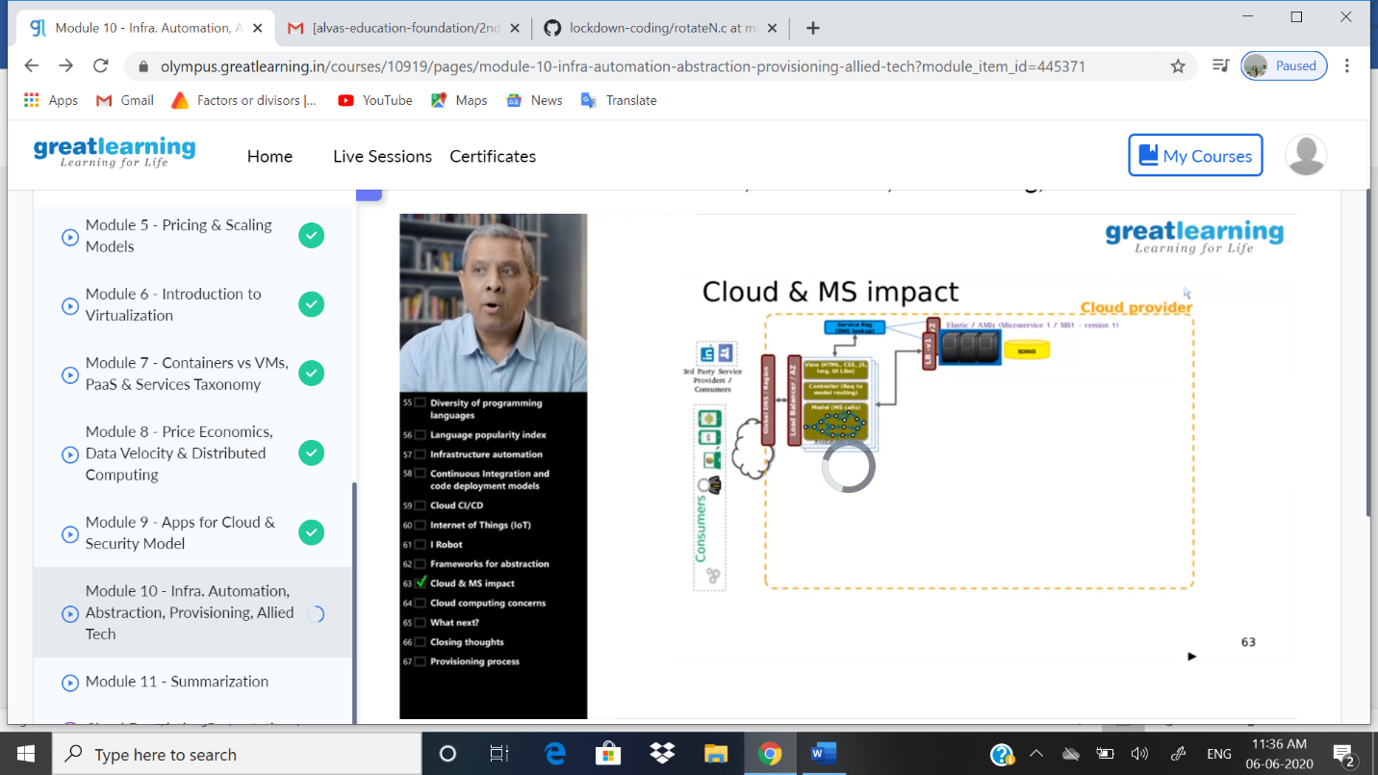

ONLINE CODING DETAILS:

PROBLEM 1: **Write a C program to rotate an array to N postion**

SNAPSHOT: